**Homework 12**

**Type in your score here 🡪 __23__ out of 23 points possible (Decomp was extra credit)**

1. (5 points) Ponder/Reflect Exercise – Reflect on what you have learned from this portion of the class. Examples of what you can do are: a brief outline of material covered, insights you gained from class or personal study, or items you feel that you need to follow up or work on. (3-5 sentences)
   1. This week I learned about the power of basic factorial designs. When we first started the class and learned about BF1, I thought that it was pretty basic, but also limited. I am excited that it has no limits. I liked the potential possibility of being able to look at more than one interaction and even consider more variables in what is given.

2. A paper report on a study sponsored by CIFOR (Center for International Forestry Research) to evaluate the effectiveness of monitoring methods related to water and soil management. Part of the study considered soil runoff data from two catchment areas (area number 37 and 92) using runoff plots classified as “undisturbed/control” and “harvested” The runoff volume was calculated at each rainfall event, with the amount of rainfall serving as an additional factor at three levels (3.5-10 mm, 10-20 mm, and >20 mm). The data, consisting of four measurements per factor-level combination is in Soilrunoff.csv. Use Excel and R to complete the following parts using α=0.05.

Do the following.

(a) Do a data decomposition and degrees of freedom of this analysis (6 points)

(b) Complete an ANOVA table showing the sum of squares, degrees of freedom, F, and P-value for each of the main effects and all interactions using R. Also, check the requirement that the residuals are normal. Make Conclusions based off of the results (3 points)

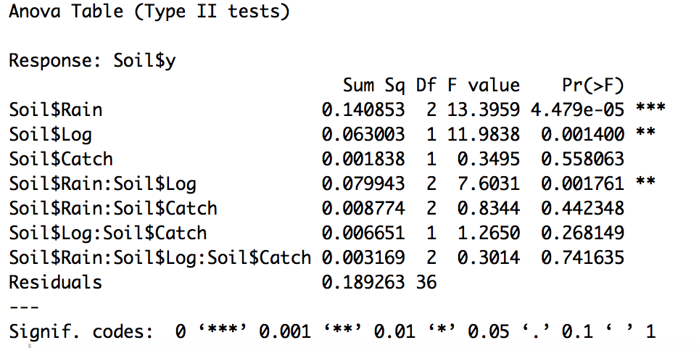

Through running the analysis we are able to see that Rain and Log are significant in that we can reject the null hypothesis that the population means are equal. With that, we are able to see that the interaction between the two of them is also significant, suggesting that we can again reject the null hypothesis that there is no interaction.

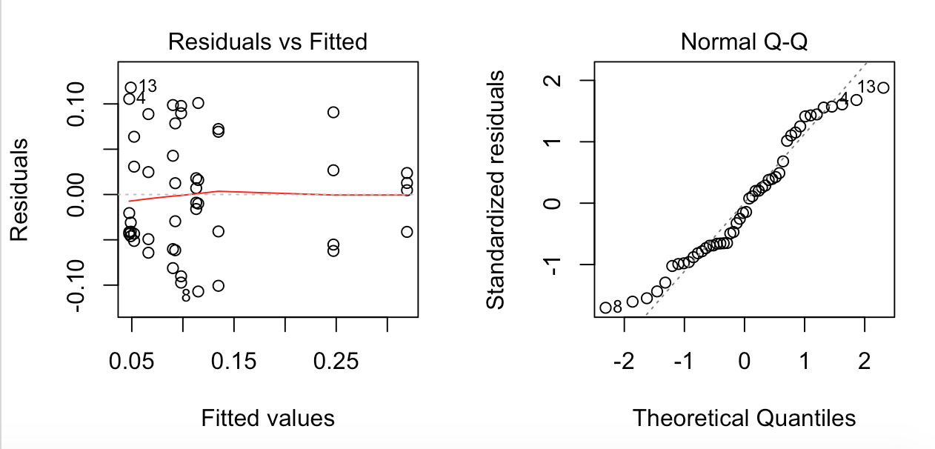

These plots tell us about normality and equal variance. The variance has a reverse megaphone shape which is bad, and the normality really trails at the ends. This is also not good. A possible transformation of log() would be appropriate to make the data more appropriate. I would reject this test as being valid if left alone.

3. A machine is used to fill 5-gallon metal containers with soft drink syrup. The variable of interest is the amount of syrup loss due to frothing. Three factors are thought to influence frothing: the nozzle design (A), the filling speed (B), and the operating pressure (C). Three nozzles, three filling speeds, and three pressures are chosen with two replicates.

Using the soft drink syrup data, do the following.

(a) Do a data decomposition and degrees of freedom of this analysis (6 points)

(b) Complete an ANOVA table showing the sum of squares, degrees of freedom, F, and P-value for each of the main effects and all interactions using R. Also, check the requirement that the residuals are normal. Make Conclusions based off of the results (3 points)

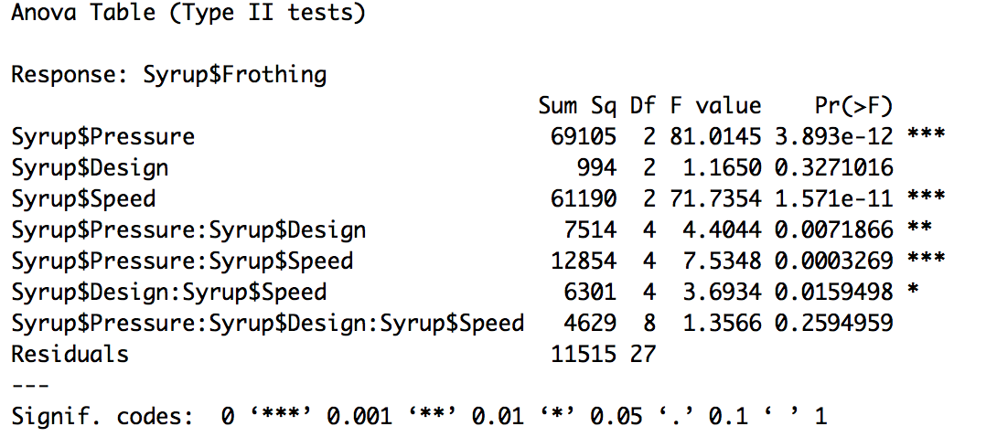

In this table we see that the pressure, speed and interactions between pressure/design, pressure/speed, and design/speed are all significant. This means that there are interactions in these cases and that Pressure and speed have groups with at least one difference in their population means. This also tells us that design does not yield significance, therefore affecting the last interaction.

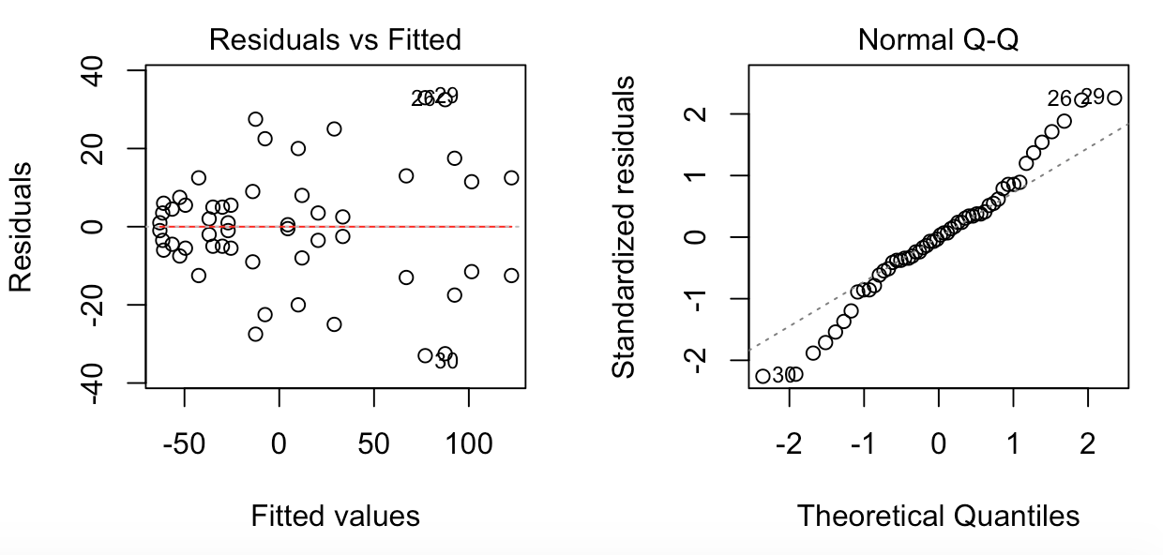

Again, these show us about the variance and normality. Both of them are equally as bad as the previous example. We have a megaphone and trailing ends on the normality plot. Again, maybe a log transformation would be affective on this data set so that we might meet the assumptions better. Again, I would not trust this analysis with the given graphs.